**Task Membuat Query**

1. SELECT * FROM `detail_penjualan` ORDER BY total_harga ASC

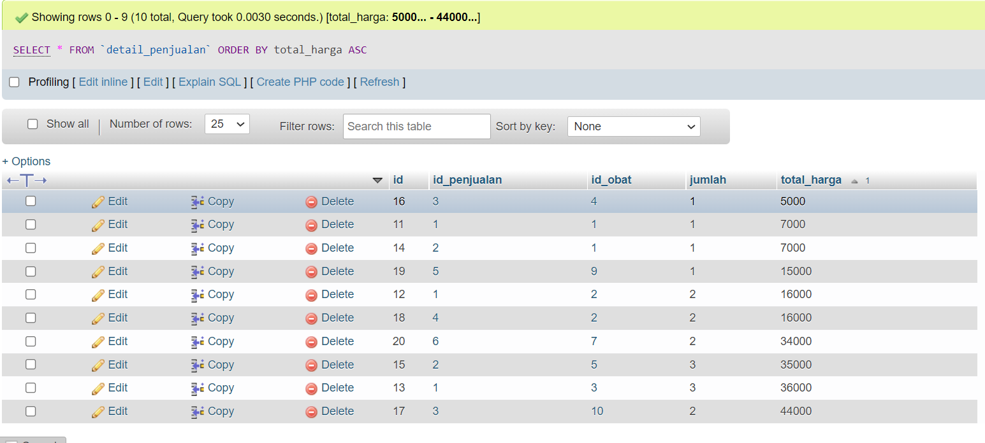

1. SELECT * FROM `detail_penjualan` ORDER BY jumlah DESC

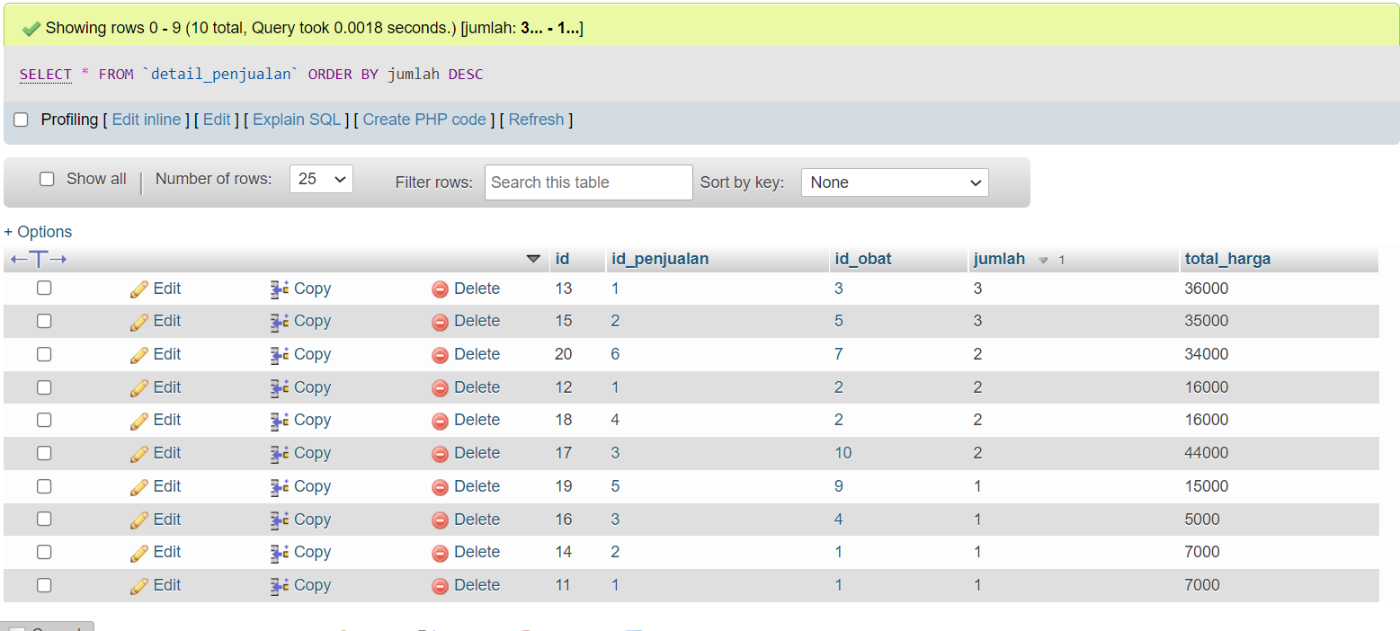

1. SELECT * FROM `pelanggan` WHERE nama LIKE `%ira%`

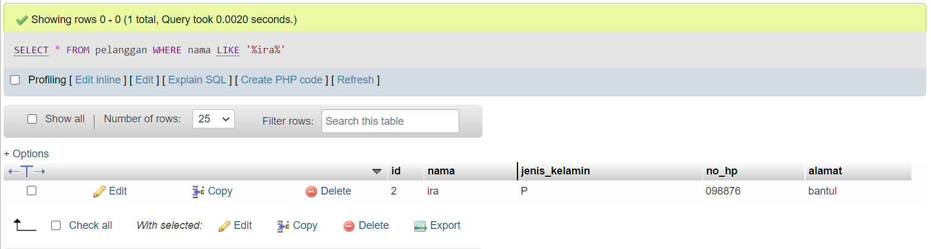

1. SELECT * FROM `pelanggan` WHERE nama LIKE `%yodi%`

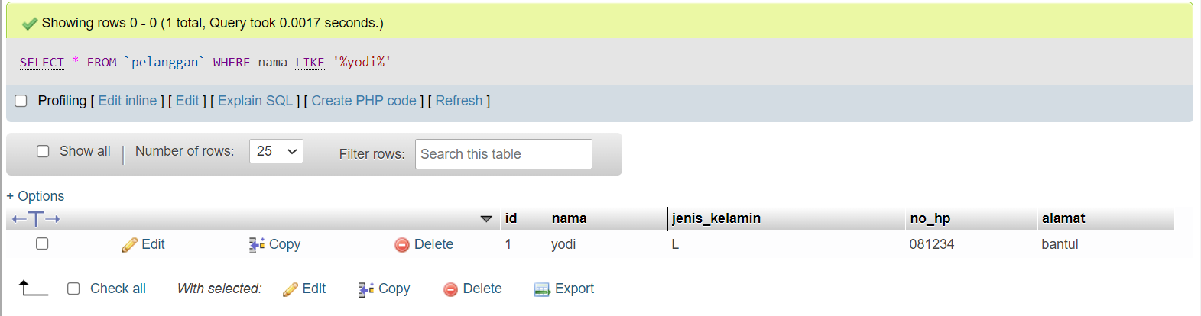

1. SELECT `id_penjualan`, SUM(total_harga) as total FROM `detail_penjualan` GROUP BY `id_penjualan`

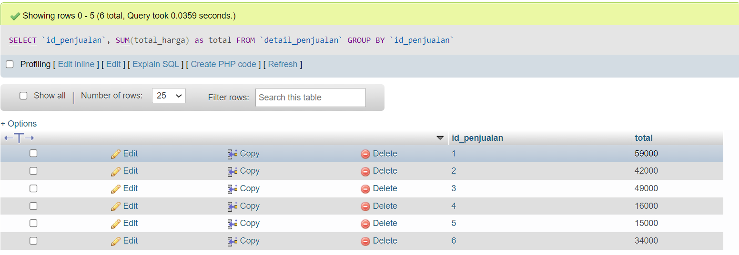

1. SELECT `id_penjualan`, SUM(jumlah) as total FROM `detail_penjualan` GROUP BY `id_penjualan`

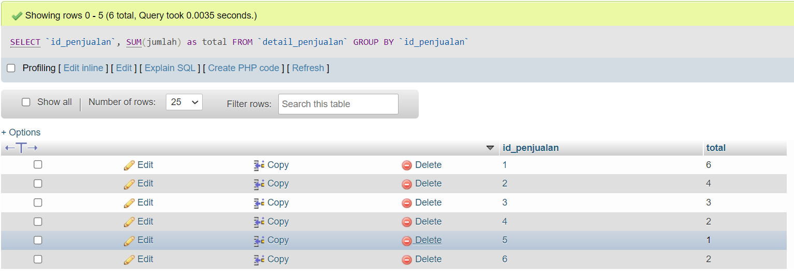

1. SELECT `id_penjualan`, SUM(total_harga) as total FROM `detail_penjualan` GROUP BY `total_harga` ASC

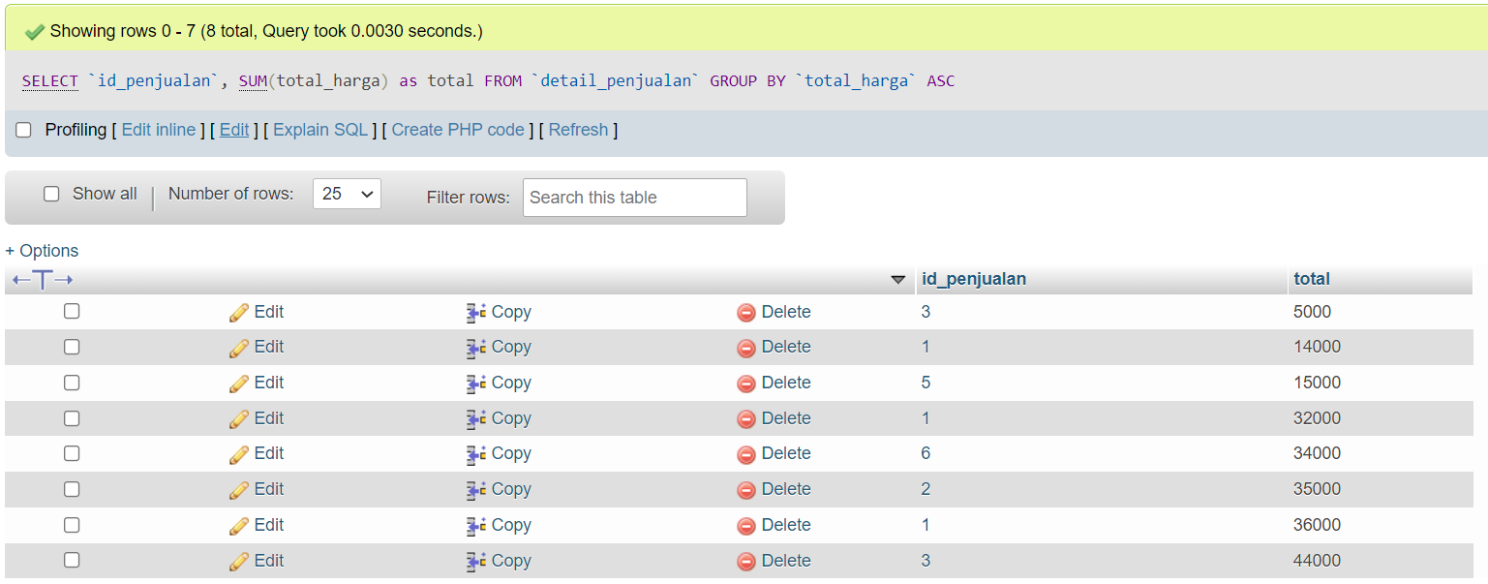

1. SELECT `id_penjualan`, SUM(total_harga) as total FROM `detail_penjualan` WHERE jumlah >= 2 GROUP BY `total_harga` ASC

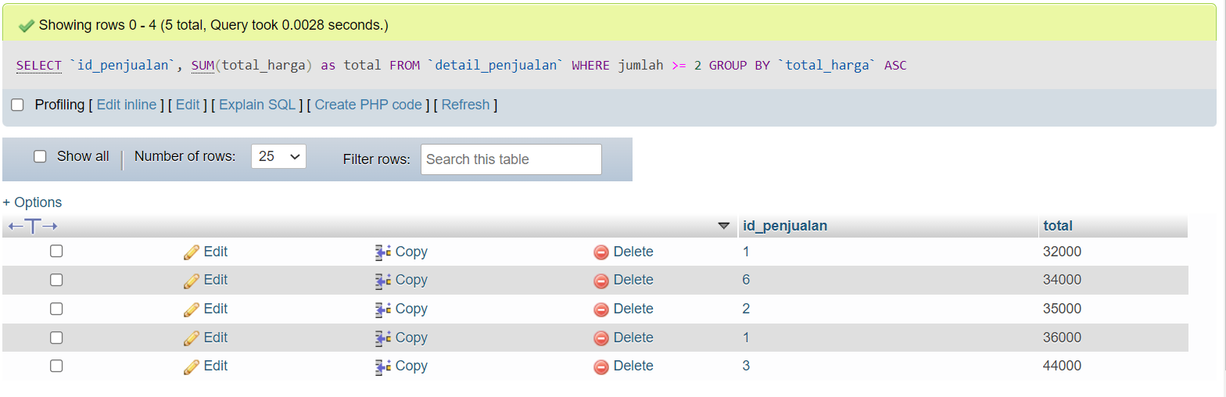

1. SELECT `id_penjualan`, SUM(total_harga) as total FROM `detail_penjualan` GROUP BY `id_penjualan` DESC

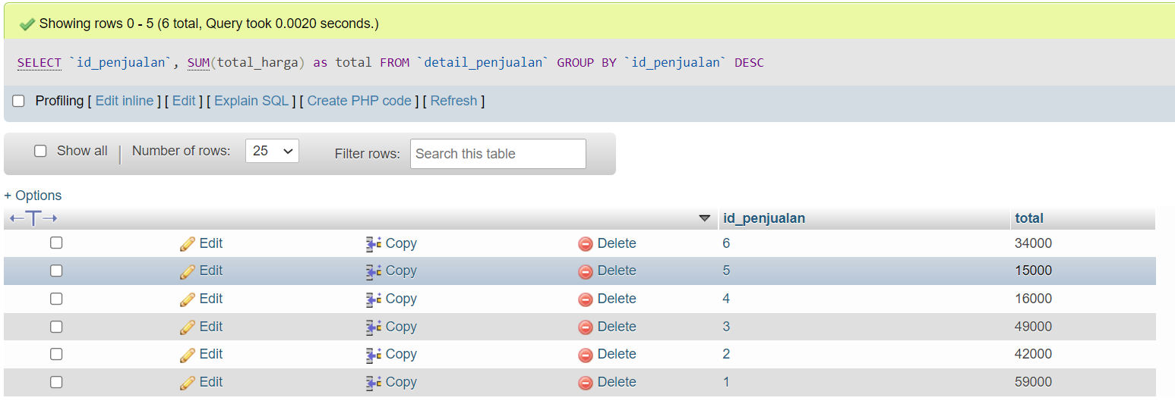

1. SELECT `id_penjualan`, SUM(total_harga) as total FROM `detail_penjualan` WHERE jumlah > 2 GROUP BY `tahun` DESC

